Sunday Fun-Day

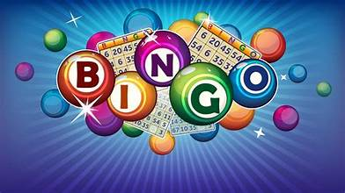

Sponsored by the “Committee for Senior Events”

Our Lady of Hope Auditorium

61-27 71st Street, Middle Village, NY 11379

www.ourladyofhopeparish.org

**Sunday, October 20, 2024**

Doors Open at 1:30 p.m.

(All adults 21+ are welcome)

**Admission: $10**

**Admission includes:** 1 packet of BINGO Cards (10 games),

Door Prizes, Light Refreshments

Please bring your own marker

We will also have Raffle Baskets, Calendar Game and a 50/50

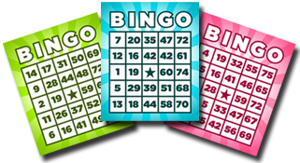

Tickets will be sold after all Masses during the weekends of

October 5th and October 6th and October 12th and 13th or

Please call Liz @ 917-864-8964 or Diana @ 718-335-2999

**(Tickets will not be sold at the door)**