**OASIS CHRISTIAN SINGLES EVENTS**

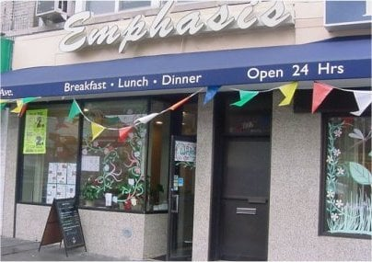

**SINGLES GET TOGETHERS OVER LUNCH**

**1pm Saturdays: June 22nd, July 20th, August 17th**

**Emphasis Restaurant Café**

**6822 4th Ave, Bay Ridge, Brooklyn, NY 11209**

[**(718) 748**](tel:7186809818) **1319**

Join Christian singles of all ages, from all walks of life and from all denominations from throughout the tri-state area for lunch. It’s that simple! Are you tired of the singles scene and want to meet some new people? Join us! Come by yourself or with friends. Our greeters will welcome you! And by the way, the food is excellent. June will be our 3rd Lunch Get Together. We had to switch restaurants because we outgrew the last one! This is a popular and fun event! Ask for our singles group when you arrive. We will be in the 2nd Room by the window. Full menu, separate checks.

R train to 69th Street, Bay Ridge Ave. stops in front of the restaurant.

**We are celebrating 27 years of hosting uplifting events for singles!**

***CompleteinChrist.com***