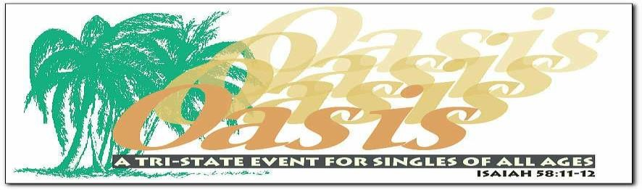
SINGLES KARAOKE NIGHT
6 PM SATURDAY, MAY 18th, 2024
Featuring Christian DJ Seven Spirits & Favor

Join Christian single adults of all ages, from all walks of life, and from all denominations throughout the tri-state area for a super fun night of karaoke with great music and lots of singing! Don’t be shy! Top performance goes home with a prize! Feel free to come alone or with friends. Church singles groups are welcome. OASIS has been hosting uplifting singles gatherings since 1997. If you are tired of the singles scene this is the place for you!

6 p.m. to 6:50 p.m. HOT CATERED BUFFET DINNER AND FRIENDLY FELLOWSHIP. Please arrive on time!
The delicious menu consists of three choices of six-foot heroes. Chicken Cutlet with Fresh Mozzarella and Roasted Peppers, Eggplant Parmigiana or Grilled Vegetables. Homemade potato salad, macaroni salad, cole slaw, and pickles will also be enjoyed. Dinner ends 6:50 PM!

7 p.m. to 8:50 p.m. KARAOKE PRESENTED BY DJ SEVEN SPIRITS & FAVOR.
Get ready for a very special night of fun karaoke like you’ve never experienced before with this dynamic duo that just happens to be married! www.DJSevenSpirits.com.

9 p.m. to 10 p.m. DESSERT AND FELLOWSHIP. OASIS is a very friendly place!

Admission: $20 at the door. No advance tickets. Doors open 5:30 p.m.

VOLUNTEERS ARRIVE 4PM This is a great way to make new friends. We need food servers, greeters, ushers, set up and clean-up crew. Volunteers eat dinner together before the event even begins.

To be added to our email or text contact list to find out about our monthly In-Person and Zoom events email Cindy@CompleteinChrist.com. We host 3 large events a year and Diner Fellowships and Pizza Luncheons.

Directions:
By Public Transportation:
- “D” train to 71st Street and New Utrecht Ave.
- “B4” bus to 14th Ave. and Bay Ridge Parkway.
- “B64” bus to Bay Ridge Parkway and 13th Ave.
By Car: Take the Belt Parkway to Exit 4 (14th Ave. Exit). Make a left onto Cropsey Ave.
Make a right onto 14th Ave. Continue on 14th Ave. to 76th Street. Make left on 76th street. church is on the corner of 14th Ave. and 76th Street. Entrance is on 76th Street.

Lefferts Park Church (Look for the OASIS entrance sign)
7524 -14th Avenue, Dyker Heights, Brooklyn NY 11228
CompleteinChrist.com

