**Spring Social for the “Young at Heart”**

**Hosted by the “OLH Committee for Senior Events”**

Sunday, April 28, 2024

2:00 p.m. – 6:00 p.m.

Our Lady of Hope Auditorium

71st Street & Eliot Avenue, Middle Village, NY

www.ourladyofhopeparish.org

Price: $25 per person

 

**Price Includes:**

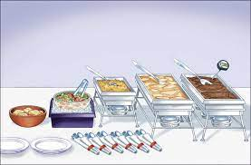



Hot Buffet, DJ, Live Music

Coffee, Tea, Cookies

BYOB

For tickets, please call:

Diana & Robert – 718-335-2999

Linda – 718-898-3222, Mary – 718-446-1554

Phyllis – 718-478-4741

Tickets will be sold after all Masses during the weekends of

April 13th and April 14th and April 20th and April 21st

Tickets **must** be purchased in advance.

Tickets **will not** be sold at the door.