Anointing of the Sick Mass
Sponsored by the “OLH Committee for Senior Events”

Saturday, March 23, 2024
1:00 p.m.

Our Lady of Hope Church
61-27 71st Street
Middle Village, NY
www.ourladyofhopeparish.org
718-429-5438

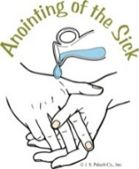

Light refreshments will be served in the
school cafeteria after Mass.

