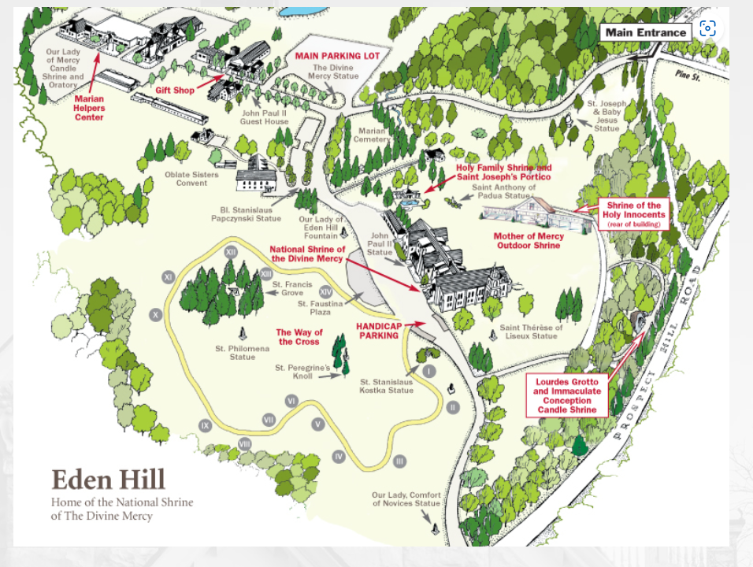

**Date:** Saturday, September 23, 2023

**Transportation:** bathroom equipped charter bus

**Cost:** $95/person. *Space is limited. The pilgrimage will be open to the entire Deanery. Seats will be reserved on a first come first serve basis. Checks made payable to American Martyrs Roman Catholic Church.*

**N.Y. Departure location/time:** American Martyrs Church parking lot @ 6:30 A.M.

(Church address: 79-43 Bell Boulevard, Bayside, NY 11364)

**M.A. Departure location/time:** Shrine parking lot @ 4:30 P.M.

**Contact:** Annabelle Villegas at 347-871-8644 or at [agapelove@latinodirect.com](mailto:agapelove@latinodirect.com) for any questions or concerns. A handicap accessible bus may be available, if needed. Please call.

**Reservation:** To reserve seat(s) **a *non-refundable*** deposit of $40/seat is required

**Full Payment due**: ***August 15, 2023***

National Shrine of the Divine Mercy Pilgrimage Stockbridge, MA

**DM**

**Shrine**

**2023**

*The National Shrine sits on 375 acres of land nestled in the Berkshire hills in western Massachusetts, known as Eden Hill.*

* **Life size Stations of the Cross**
* **Explaining the Faith Talk w/ Fr. Chris Alar – Livestreamed on YouTube**
* **Mass**
* **Confessions**
* **Adoration & Rosary**
* **Benediction**
* **Blessing of religious articles**
* **Blessing with first class relic of St. Faustina**
* **Lourdes Grotto**
* **Shrine of the Holy Innocent**
* **Gift Shop**
* **and so much more**