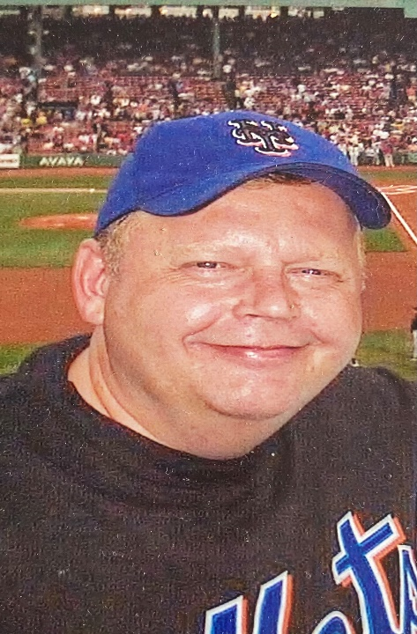
FATHER CHRIS GAME
Sunday July 16th @ 2pm
BROOKLYN CYCLONES vs Greensboro
1904 Surf Ave in Coney Island
Please join his family, friends and parishioners
at one of his favorite places!

Law Enforcement Appreciation Day
Six-Can Cooler Pack First 1,000 Fans
Ice Cream Sunday - the first 500 kids (14 & under) will receive FREE Dippin' Dots
Kids Run the Bases - Stick around after the game for Kids Run the Bases

Questions contact: Billy Cashman – 646-235-2646
Bull McGrann - tappenct@aol.com

For tickets: fevo.me/3X4xKP5
