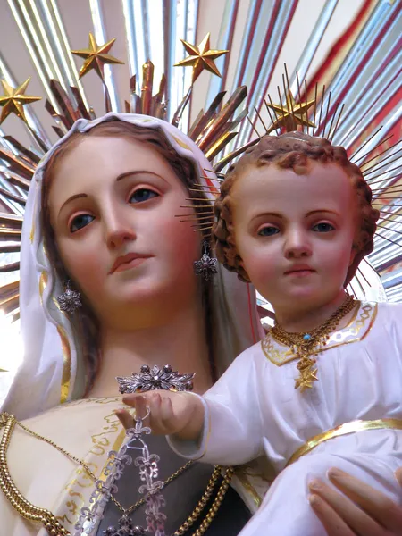
The Lay Carmelite
Community
of Our Lady of Angels
invites you to
“COME AND SEE’
what the Lay Carmelites
are all about.

Learn about our charism, our history, contemplative prayer, the responsibilities, and the total joy of membership in one of the Church’s oldest and holiest orders.

Saturday, June 10th, 2023
1:00 – 3:00 PM
Our Lady of Angels Church
7320 – 4th Avenue
Brooklyn, New York 11209
In the Cavanagh Room
For more info please call 917-921-0217

