SAVE THE DATE!
ST.CLARE’S CHURCH BUS TRIP
SIGHT & SOUND THEATER,LANCASTER ,PA.
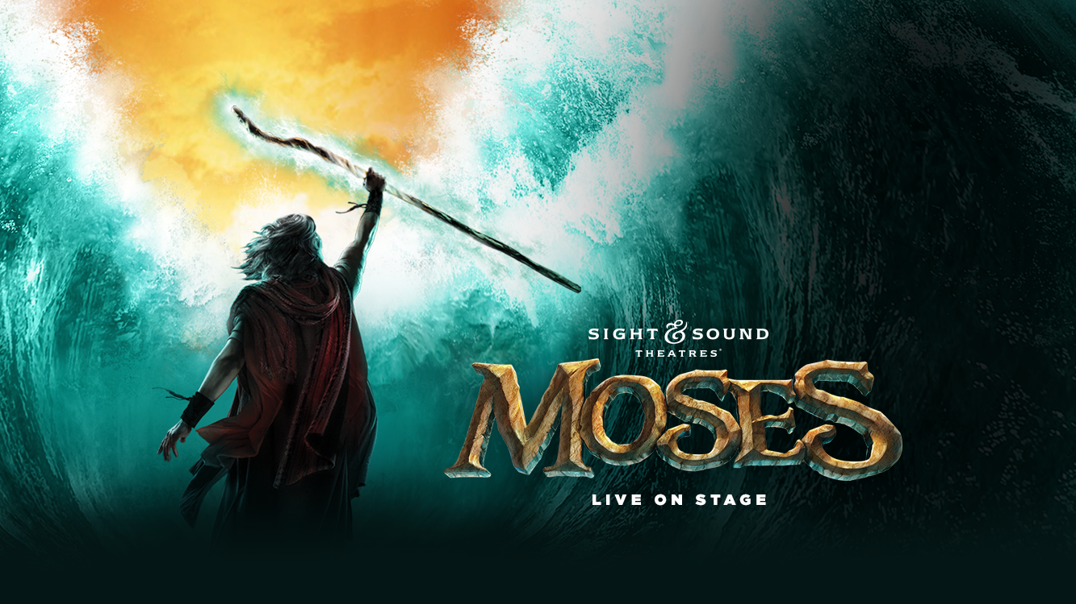
DATE : SATURDAY – SEPTEMBER 23, 2023
PICKUP TIME: 8:00 AM –Be on time , will not wait for late arrivals
WHERE: 137-35 BROOKVILLE BLVD, ROSEDALE at ST. CLARE’S CHURCH
COST: ADULTS- $ 200.00
Due to rising prices at Sight n Sound – Payment plan available !
1ST PAYMENT BY 3/5/20 –Deposit must be given to BUS COMPANY
FINAL PAYMENT DUE BY 8/14/23.( No Refunds )
BRING PAYMENT TO RECTORY OFFICE ,
REVIEW BUS SEATING PLAN WITH FINAL PAYMENT
ITINERARY: ALL YOU CAN EAT LUNCH BUFFET AT GOLDEN CORRAL
SIGHT AND SOUND SHOW - MOSES
LANCASTER,PA

