legion of mary
51st ANNUAL CROWNING OF MARY
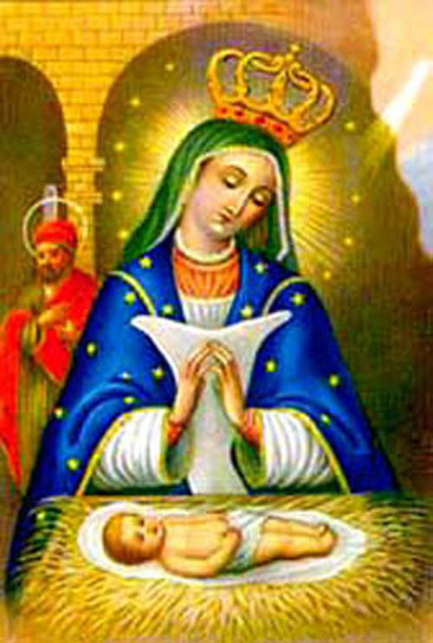
SUNDAY, MAY 7TH, 2023 AT THE 9am MASS
OUR LADY OF THE PRESENTATION ROMAN CATHOLIC CHURCH
1677 SAINT MARKS AVENUE
AT THE INTERSECTION OF ROCKAWAY AVENUE
AND EASTERN PARKWAY
BUS: B60 TO DEAN STREET
SUBWAY: C TRAIN TO ROCKAWAY AVENUE AND WALK SOUTH
RECEPTION WILL BE IN THE RECTORY AFTER MASS
FOR MORE INFORMATION PLEASE CALL (718)345-2604
EMAIL: olpres@optimum.net
Please wear any shade of blue if possible
(Por favor, use cualquier tono de azul posible)

You’re Invited to Celebrate with Us! (Estas invitado a celebrarlo con nosotros)

